**Scaling Down Scrum**

**Agile Adaptations in Finco's Small Team Development**

*a case-study*

1. **Introduction**
2. **Premise**
3. **Roles and Responsibilities**
4. **Team Composition and Communication**
5. **Initial Planning and Backlog**
6. **Sprint Planning and Execution**
7. **Challenges and Adaptations**
8. **Conclusion**

**Introduction**

This case study presents an insight into the development of Finco, a personal finance tracking app, created by a small, agile team of 3 students. Our aim was to design an app that streamlines financial management, offering features like transaction tracking and budget planning, all within a user-friendly interface.

**Premise**

Embarking on this project, we faced the challenge of applying Scrum methodology in a small-team context. With a focus on adaptability and rapid development, this study explores how we tailored traditional Agile practices to our compact setup. It's a journey through problem-solving and teamwork, reflecting the potential of Scrum to drive efficient development, regardless of team size or project scope.

**Roles and Responsibilities**

In our team, the traditional Scrum roles were not rigidly defined. Instead, we embraced a more fluid approach where responsibilities overlapped. The role of the Scrum Master, for instance, was informally adopted by our Git-master, who not only managed code merges but also facilitated our daily meetings and discussions. This flexible role distribution was key to our project's success, allowing us to remain nimble and responsive throughout the development process.

We collectively embodied the Product Owner role, with each team member engaging directly with stakeholders like teachers and test users. This involvement ranged from individual interactions to team-facilitated feedback sessions, sometimes including stakeholders in our meetings for direct input.

**Team Composition and Communication**

A key aspect of our project's success was the communication strategy we adopted. Every morning, we held a video chat meeting for our daily standup and sprint planning. This routine helped us align our goals and tasks for the day, ensuring everyone was on the same page.

Beyond these structured meetings, we kept an open audio channel on Discord throughout the workday. This channel, where team members stayed online and muted, allowed for quick communication. Anyone could unmute and ask questions or seek assistance at any moment. This setup was instrumental in swiftly addressing issues and facilitating real-time collaboration, significantly enhancing our problem-solving efficiency and team dynamics.

**Initial Planning and Backlog**

In the early stages, our team's focus was on dissecting the provided Figma designs and conceptualizing Finco's user interface and functionalities. This process involved breaking down the design into individual components, which then formed the basis of our product backlog. Our initial user stories were centered around foundational tasks such as setting up the project environment, establishing the database, and creating a data model. These initial steps were crucial in laying the groundwork for a stable and scalable app architecture.

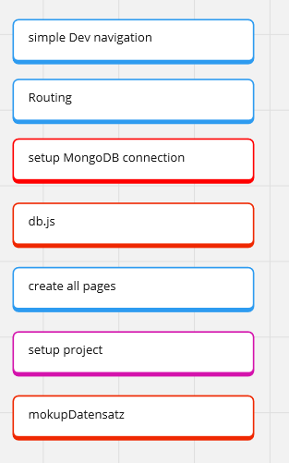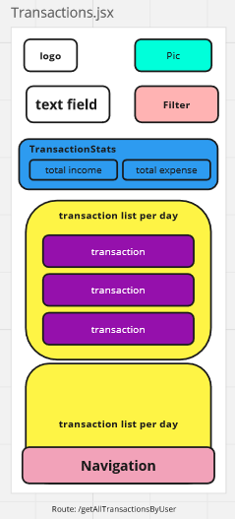Breaking down Figma design: Initial Product backlog items:

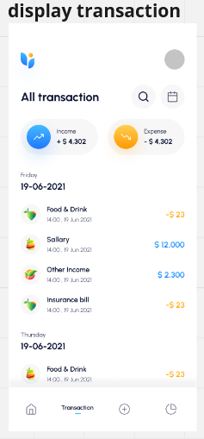

**Development Process and Tools:**

Our primary tool for organizing tasks and tracking progress was a Miro board. This versatile platform enabled us to break down the Figma designs into components, create a comprehensive product backlog, and set up a Kanban board for workflow management. We also used it for detailing our database structure and endpoint specifications among other things.

The Miro board we were using:

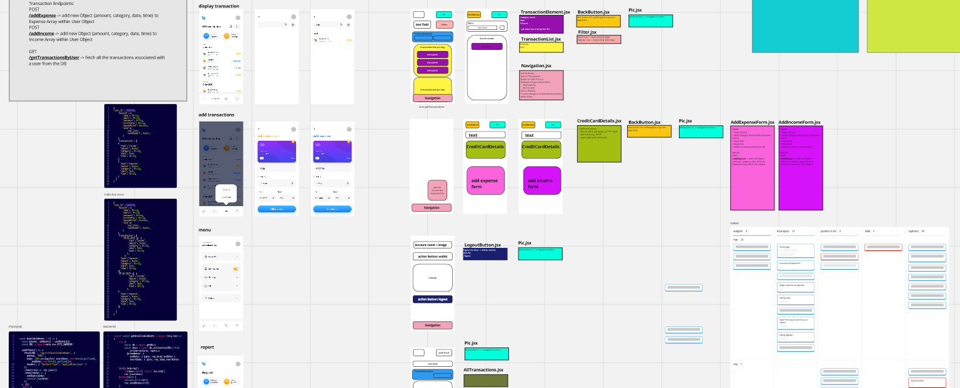

**Early Sprints - Infrastructure and Backend:**

In the initial stages, our sprints were heavily focused on setting up the necessary infrastructure and backend components. This included tasks like establishing the webserver, creating database connections, setting up the database, and writing endpoints for user and transaction data management. We also implemented basic security features such as password hashing and cookies. The primary goal was to create the most basic, functional version of Finco as outlined in the initial design.

**Design Adaptation and User Feedback:**

We found ourselves revisiting and altering some initial design choices to enhance user friendliness and intuitiveness. This iterative design process was driven by real user feedback. We provided the app to acquaintances for testing, using their insights to refine our UX decisions, ensuring that Finco was not only functional but also appealing and easy to use.

**Later Sprints - Feature Addition and Refinement:**

As we progressed, later sprints shifted focus towards feature enhancement, design improvement, and code refactoring. This phase involved adding new capabilities like advanced reporting features, improving the app's design and responsiveness, and refining the codebase. Critically, this phase also involved implementing lessons learned from user feedback, ensuring that the app not only met but exceeded user expectations in terms of functionality and user experience.

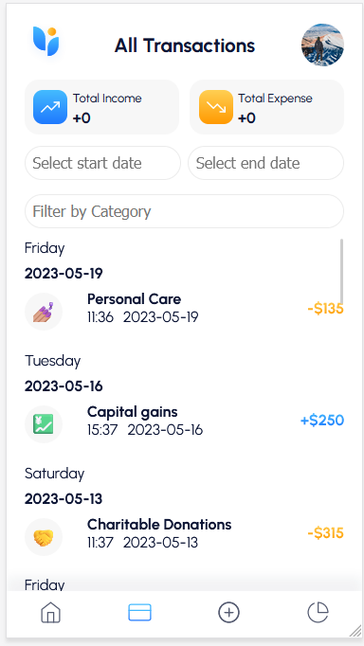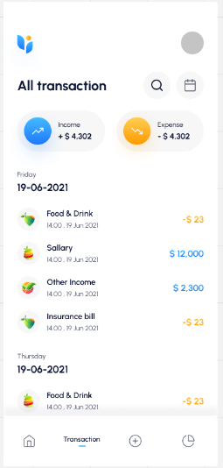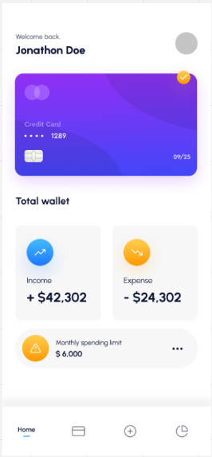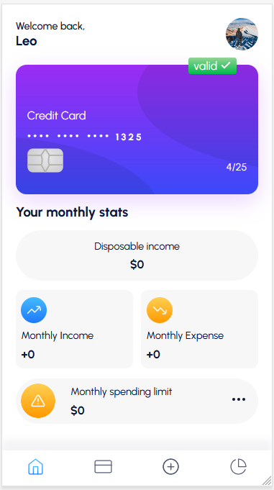Initial design: Adapted design:

**Challenges and Adaptations**

As students, having no practical experience with the full application of Scrum, we began our project without fully defined roles.

This presented our first challenge: structuring our workflow effectively. We responded by embracing daily meetings and maintaining a constant open line of communication through a Discord voice channel remaining open during work hours. This setup proved crucial for quickly addressing technical issues like deployment challenges and merge conflicts.

Responsiveness was another challenge, especially in ensuring the app's functionality across various devices and environments. We actively sought feedback from test users, using their insights to make iterative improvements to Finco in progressing daily sprints.

Finally, to address the issue of inconsistent coding practices, we established a few standardized function templates for front and backend as well as design standards. This not only improved the readability of our code and consistency in design, but also made collaboration more efficient, as everyone was now working with a familiar structure.

Design guideline:

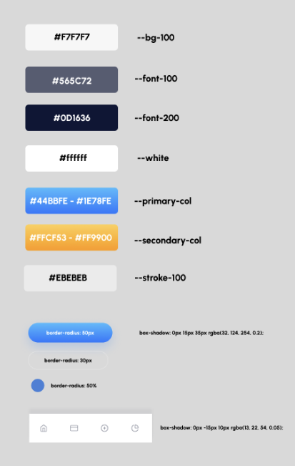

**Conclusion**

In our Finco project, we reshaped Scrum to fit our rhythm and needs, a crucial step for our small, student-led team. Daily sprints became our version of Scrum events, and we all stepped into Product Owner roles, with our Git-master acting as a de facto Scrum Master. This adapted framework, coupled with our open communication and iterative approach using story cards, greatly eased our initial apprehension about tackling such a significant project in such a short time frame.

What stood out was the supportive and inclusive environment we cultivated. Questions and collaboration were encouraged, creating a space free from judgment, vital for our learning and development as aspiring software professionals. This experience taught us the value of flexibility within Scrum, demonstrating that even parts of the framework, when creatively applied, can bring immense value to small teams and tight deadlines. Our journey with Finco underlines a key lesson: Scrum isn't a one-size-fits-all solution, but a flexible toolkit that, when modified to meet specific project needs, can drive success in software development, regardless of team size or experience level.